*Future Educators of America*

*April 2013*

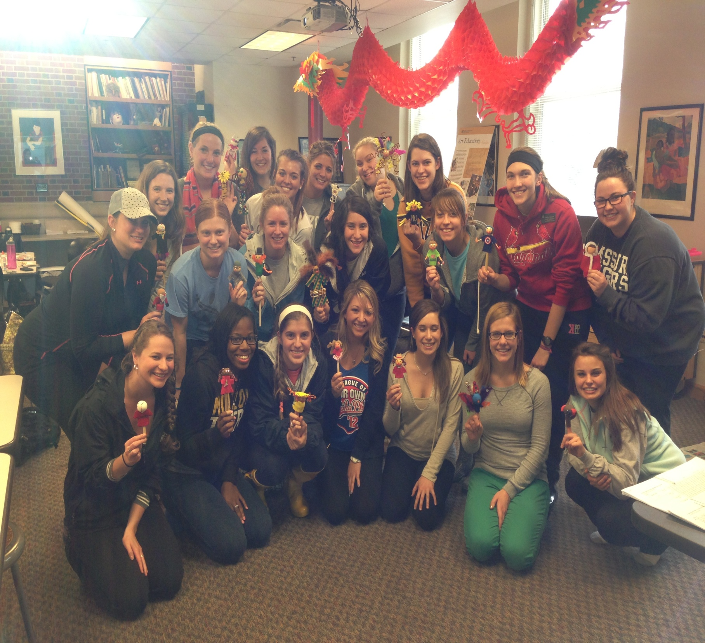

**Bright young college students at the University of Missouri work hard to earn their degree by completing a variety of assignments that will make them better teachers.**

